Command

1. Echo:- display lines of text or strings that are passed as arguments. It is commonly used in shell scripts and batch files to output status text to the screen or a file.

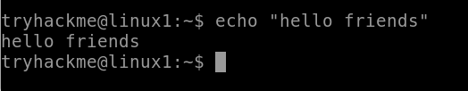



1. Whoami:- The whoami command allows Linux users to see the currently logged-in user. The output displays the username of the effective user in the current shell. Additionally, whoami is useful in bash scripting to show who is running the script.



1. ls (Listing) :- ls is a Linux shell command that lists directory contents of files and directories. It provides valuable information about files, directories, and tls is a Linux shell command that lists directory contents of files and directories. It provides valuable information about files, directories, and their attributes.

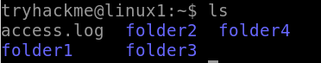

1. cd (change directory) :- The cd command in Linux stands for change directory. It is used to change the current directory of the terminal. The terminal, by default, opens the home directory.



1. pwd:- pwd stands for Print Working Directory. It prints the path of the working directory, starting from the root.

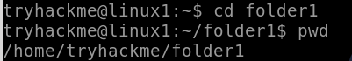

1. cat :- Cat(concatenate) command is very frequently used in Linux. It reads data from the file and gives its content as output. It helps us to create, view, and concatenate files. So let us see some frequently used cat commands.

* To view a single file:-

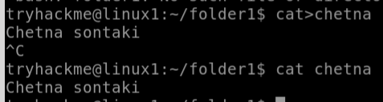

* To view multiple files:-

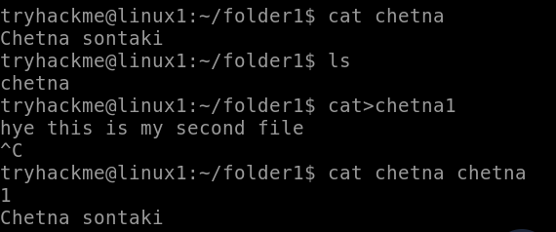

* To view content of a file preceding with line number:-



* Create a file and add content:-



* Copy the contents of one file to another file:-

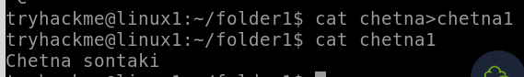

* Cat command can append the contents of one file to the end of another file.

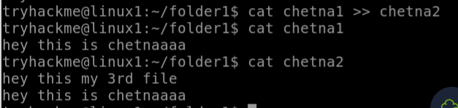

* Cat command can display content in reverse order using tac command.

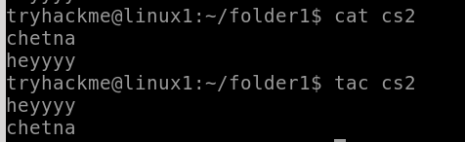

* Cat command can highlight the end of line.

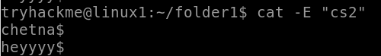

1. Find :- The find command helps us to find a particular file within a directory. It is used to find the list of files for the various conditions like permission, user ownership, modification, date/time, size, and more

